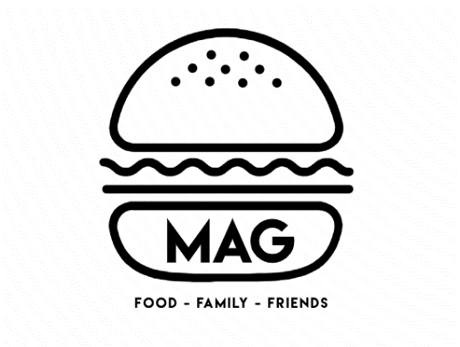

MAG Burgers

MAG Beef Burgers

The O.G (12.95)
2 x Premium MAG Beef Brisket & Chuck Smashed Patties, Secret Seasoning, American & Jack Cheese, Artisan Burger Bun,

The Classic Original (13.95) Lighter Option (10.95)
Premium MAG Beef Brisket & Chuck Smashed Patties, Secret Seasoning, American & Jack Cheese, Bistro Salad, Sliced Beef Tomato, Ketchup, American Mustard, Artisan Burger Bun.
Original 2 x Patties. Lighter Option – 1 x Pattie.

The Banwen Belter Original (14.95) Lighter Option (11.95)
Premium MAG Beef Brisket & Chuck Smashed Patties, Secret Seasoning, American & Jack Cheese, Bistro Salad, Sliced Beef Tomato, Smoked Streaky Bacon, Pickles, Burger Sauce, Artisan Burger Bun.
Original 2 x Patties. Lighter Option – 1 x Pattie.

The Freaky Founders Original (14.95) Lighter Option (11.95)
Premium MAG Beef Brisket & Chuck Smashed Patties, Secret Seasoning, American & Jack Cheese, Smoked Streaky Bacon, Garlic Mayo, Sriracha, Spring Onions, Mixed Sliced Chillies, Fresh Coriander, Artisan Burger Bun.
Original – 2 x Patties. Lighter Option – 1 x Pattie.

NB. Original – 2 x Patties. Lighter Option – 1 x Pattie

NB. Lighter Option Burgers served with American Cheese only.

MAG Fried Chicken Burgers

The O.G Chix (12.5)
2 x Secret Recipe MAG Buttermilk Fried Chicken Breast Strips, Jack Cheese, Artisan Burger Bun,

The Cluckers (13.5)
2 x Secret Recipe MAG Buttermilk Fried Chicken Breast Strips, Jack Cheese, Smoked Streaky Bacon, Pickles, Burger Sauce, Artisan Burger Bun,

The Hot Chix (13.5)
2 x Secret Recipe MAG Buttermilk Fried Chicken Breast Strips, Jack Cheese, Smoked Streaky Bacon, Chilli Jam, Fresh Coriander, Artisan Burger Bun,

MAG Veggie Burger

The Halloumi Burger (13.5) V
5 x Chunky Halloumi Fries, Chilli Jam, Fresh Coriander, Garlic Mayo, Artisan Burger Bun,

The Hulk Smash (12.95) VG
Vegan burger made with Broad Beans, Peas, Spinach & Aromatic Spices. Salad Leaves, Sliced Tomato, BBQ Sauce, Fresh Coriander, Vegan Burger Bun.

Burger Upgrades – Why not add something extra to your favourite burger?

1 x Premium MAG Beef Brisket & Chuck Smashed Pattie, Secret Seasoning, American Cheese (4)
2 x Secret Recipe MAG Buttermilk Fried Chicken Breast Strips, Jack Cheese (5)
1 x Smoked Streaky Bacon (1.5)
Ketchup (1) Chilli Jam, BBQ Sauce, Garlic Mayo, Sriracha (2)

MAG Secret Recipe Buttermilk Fried Chicken

The Original & Dip 3 x Strips (8.95)
Secret Recipe Buttermilk Fried Chicken Breast Strips, Fresh Chives & 1 x pot of either Chilli Jam, BBQ Sauce, Garlic Mayo, Sriracha or Tomato Ketchup.

The Backyard BBQ Chicken 3 x Strips (8.95)
Loaded Secret Recipe Buttermilk Fried Chicken Breast Strips, BBQ Sauce, Garlic Mayo, Fresh Chives.

The Firecracker Chicken 3 x Strips (9.45)
Loaded Secret Recipe Buttermilk Fried Chicken Breast Strips, Sriracha, Garlic Mayo, Red Chillies, Spring Onions, Fresh Coriander.

The Strip Combo (13.95)
3 x Secret Recipe Buttermilk Fried Chicken Breast Strips, BBQ Sauce, Garlic Mayo, Fresh Chives, Seasoned Skin on Fries.

MAG Fries

Loaded Firecracker Fries (9) Tots (9)
Secret Recipe Buttermilk Fried Chicken Breast Strips, Sriracha, Garlic Mayo, Mixed Chillies, Spring Onions, Fresh Coriander, Seasoned Skin on Fries.

Loaded Backyard BBQ Fries (8.75) Tots (8.75)
Secret Recipe Buttermilk Fried Chicken Breast Strips, BBQ Sauce, Garlic Mayo, Fresh Chives, Seasoned Skin on Fries.

Seasoned Skin on Fries (4) VG/GF
Seasoned with Dried Mixed Herbs, Salt & Cracked Black Pepper

Seasoned Tater Tots (4) VG/GF
Seasoned with Dried Mixed Herbs, Salt & Cracked Black Pepper

Halloumi Fries (8.95) V/GF
5 x Chunky Deep-Fried Halloumi Fries, Chilli Jam, Fresh Coriander

Mini MAG Menu

Kids Cheeseburger & Fries (7)

Kids Fried Chicken Strips & Fries (8)

Kids Halloumi Fries & Fries (7) V

MAG Lunch Deal

Cheeseburger & Fries (7.5)
1 x Premium MAG Beef Brisket & Chuck Smashed Pattie, Secret Seasoning, American Cheese, Burger Sauce, Artisan Burger Bun, Seasoned Skin on Fries.

Halloumi & Fries (7.5)
3 x Chunky Halloumi Fries, Garlic Mayo, Fresh Coriander, Salad Leaves, Seasoned Skin on Fries.

